




SUNDARBANS TOUR
Day Wise Itinerary:
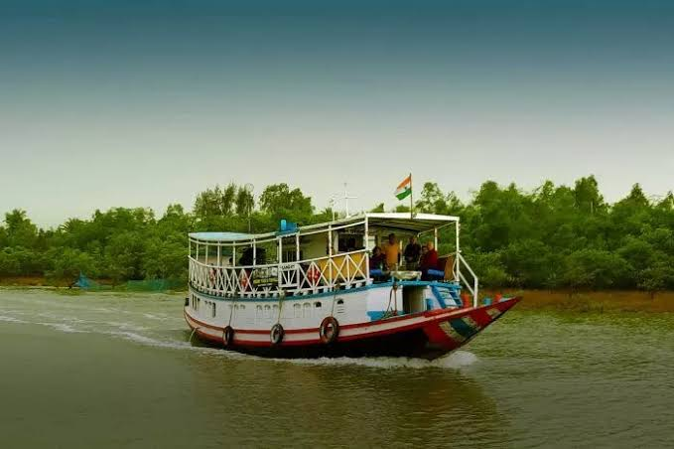
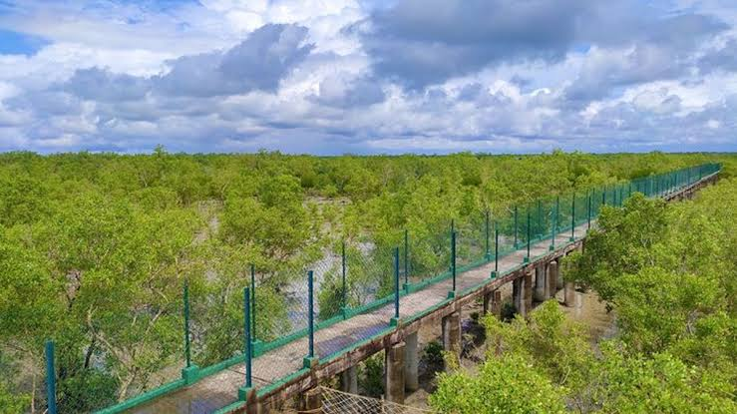
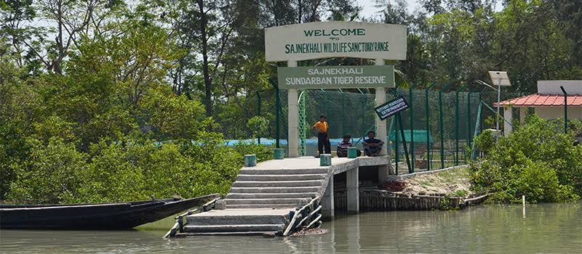

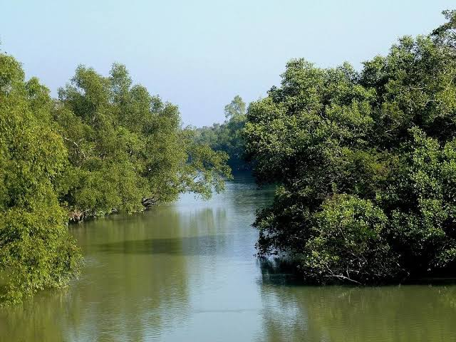
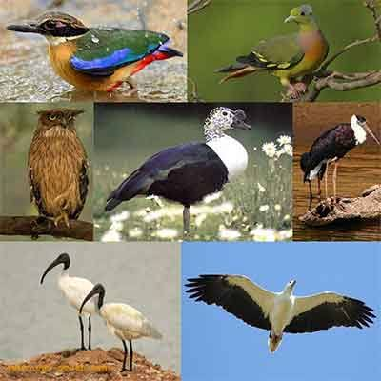

(1st Day) Sightseeing – Tatanagar to Godkhali

- Short boat journey to the Sundarban Bird Jungle

- Local culture folk dance performance

- Boat journey into the heart of the Sundarbans

- Jungle Safari starts at Sajnekhali Tiger Reserve

- Boat safari, exploring rivers, islands

- Visit Banbibi Varani, Sundarkhali, Deualvarani, Khonakhali SarakKhali, Pirkhali, Choragaji and Sudhanyakhali Watch Tower.

(2nd Day) Sightseeing

- Visit Do-Banki Tiger Reserve Area

- Visit Panchamukhni, the junction of 5 rivers

- Reach Pakhiralay and National Park Safari

(3rd Day) Sightseeing

- Visit local Sundarbans community.

- Visit Hamilton Bungalow & Rabindranath Tagore Bungalow

- Visit Ganga Aarti in Kolkata

- After Dinner Back to Tatanagar

Package Inclusion:
- Meals as per itinerary (B+L+D)
- Stay Including the AC Hotel
- Comfortable Air Conditioned vehicle
- Train Ticket
- Package cost *7,300* /Rs.

Package Excluded:
- Personal Expenses

Cancellation Policy :
- Minimum Cancellation is Rs. 1000/- per Head.
- 25% Between 30-20 Days Before Tour Departure
- 50% Between 20-10 Days Before Tour Departure
- 75% Between 10-05 Days Before Tour Departure
- 100% on the Same Day & No show.

