
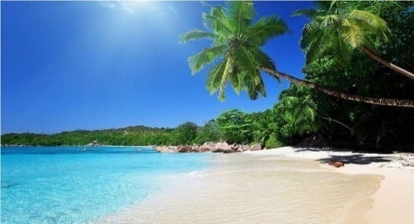



Digha Budget Tour

3 Days & 2 Night- Day Wise Itinerary:

Stay
New Digha

Destination Covered
- Jagannath Temple
- Chandaneswer Temple
- Marine Aquarium
- Science Centre
- Kajal Dhigi
- Dheusagar Park
- Amravati Park

(1st Day)

- Tata to Kharagpur by AC Chair car Train
- Kharagpur to New Digha by AC vehicle
- Arrive Hotel at 1 PM.
- Lunch at hotel
- Enjoy in Sea beach
- Dinner at hotel and then rest at hotel

(2nd Day)

- After Breakfast Hotel Pickup
- Visit :
Chandaneswer Temple
Marine Aquarium
Science Centre
Kajal Dhigi
- Lunch at hotel
- After lunch visit:
Dheusagar Park
Amravati Park
- Hotel Drop, Dinner at hotel and then rest at hotel

(3rd Day)
- After Breakfast Hotel Pickup
- Visit :
Jagannath Temple

- Note: if time in hand, will visit Udaypur Beach
Package Inclusion:
- Meals as per itinerary (B+L+D)
- 3 days & 2 Night Stay Including the AC Deluxe / Semi deluxe Room
- Comfortable Air Conditioned vehicle
- English speaking Guide and Driver
- All Museum Entry & Permit
- Package cost *7,300* /Rs.

Package Excluded:
- Personal Expenses

Cancellation Policy :
- Minimum Cancellation is Rs. 4000/- per Head.
- 25% Between 30-20 Days Before Tour Departure
- 50% Between 20-10 Days Before Tour Departure
- 75% Between 10-05 Days Before Tour Departure
- 100% on the Same Day & No show.

